Shapes

📘 Definition
# Source: AI Source: Provided by: [Data Path: Persons Table -> ID Column: 1, Name_En Column: Motasem Essam] -> From: [ChatGPT] on [5/2/2026]
Shapes are the outlines or forms of objects created by connecting lines, curves, or surfaces. They describe how something looks in 2D (flat) or 3D (solid space).

🔷 Types of shapes
# Source: AI Source: Provided by: [Data Path: Persons Table -> ID Column: 1, Name_En Column: Motasem Essam] -> From: [ChatGPT] on [5/2/2026]
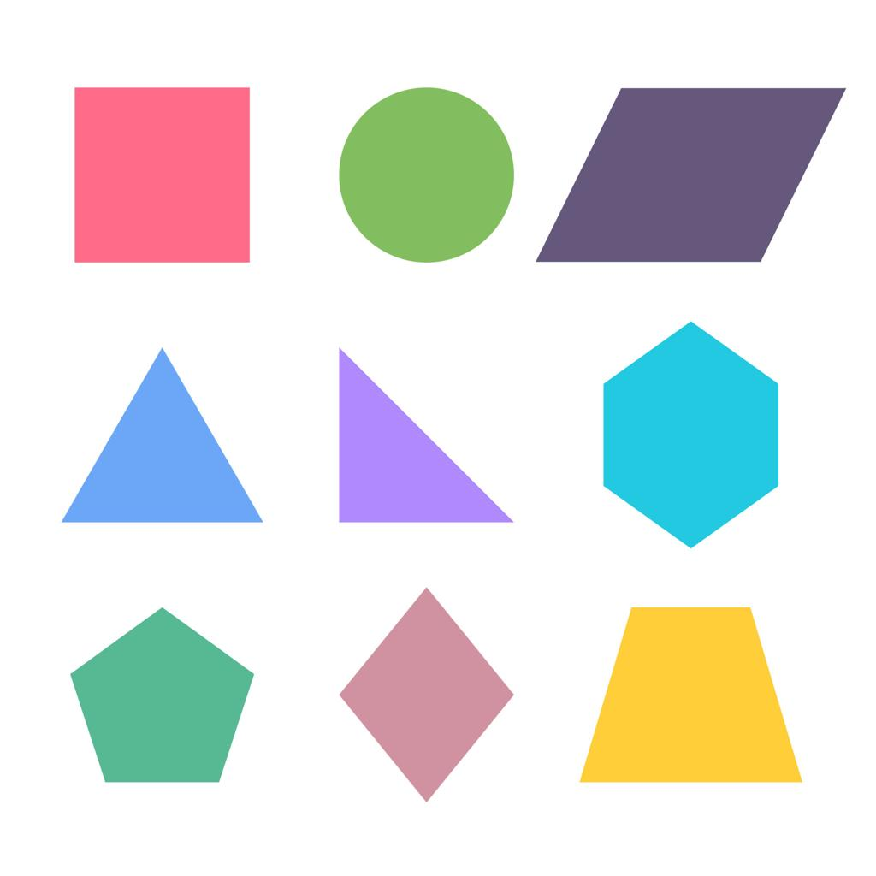

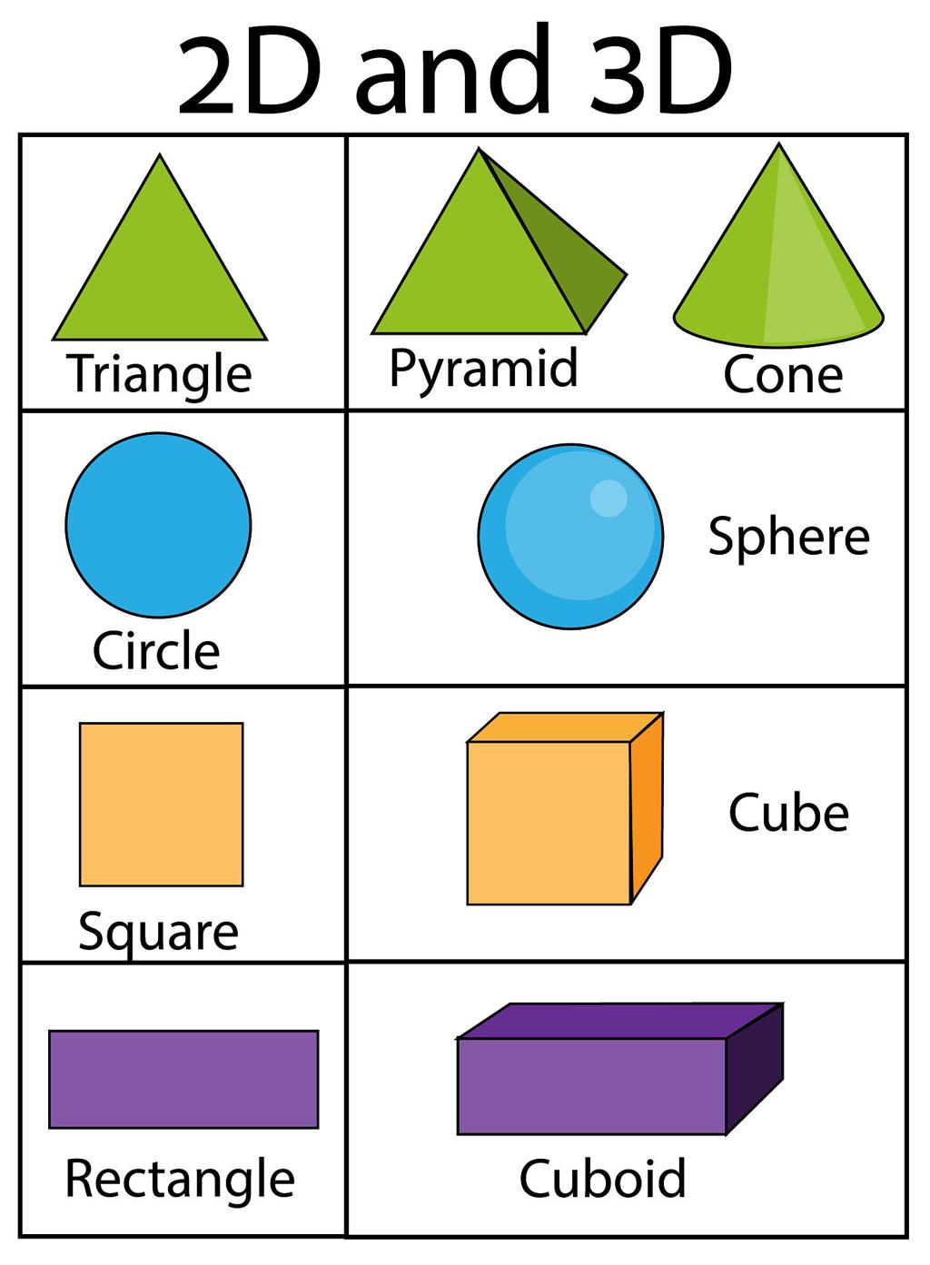

📐 1. 2D Shapes (Flat shapes)
# Source: AI Source: Provided by: [Data Path: Persons Table -> ID Column: 1, Name_En Column: Motasem Essam] -> From: [ChatGPT] on [5/2/2026]
- Have length and width only
- No thickness or depth
- Examples:
  - 🔺 Triangle
  - ⬜ Square
  - ⚪ Circle
  - ▭ Rectangle

🧊 2. 3D Shapes (Solid shapes)
# Source: AI Source: Provided by: [Data Path: Persons Table -> ID Column: 1, Name_En Column: Motasem Essam] -> From: [ChatGPT] on [5/2/2026]
- Have length, width, and height (depth)
- Look like real objects
- Examples:
  - 🟦 Cube
  - ⚽ Sphere
  - 🧴 Cylinder
  - 🔺 Cone

🧠 Simple example
# Source: AI Source: Provided by: [Data Path: Persons Table -> ID Column: 1, Name_En Column: Motasem Essam] -> From: [ChatGPT] on [5/2/2026]
- 📄 A drawing on paper → 2D shape
- 🎲 A dice → 3D shape (cube)
- ⚽ A football → 3D shape (sphere)

🎮 Shapes in computer graphics
# Source: AI Source: Provided by: [Data Path: Persons Table -> ID Column: 1, Name_En Column: Motasem Essam] -> From: [ChatGPT] on [5/2/2026]
Shapes are used to:
- Build 3D models and environments
- Create characters and objects in games
- Design UI icons and graphics
- Form the base of all visual design

📘 How to Represent Shapes
# Source: AI Source: Provided by: [Data Path: Persons Table -> ID Column: 1, Name_En Column: Motasem Essam] -> From: [ChatGPT] on [5/2/2026]
Shapes can be represented in different ways depending on whether they are 2D or 3D, and whether you are drawing them, designing them, or using them in computer graphics.

✏️ 1. 2D Shape Representation (Flat Shapes)
# Source: AI Source: Provided by: [Data Path: Persons Table -> ID Column: 1, Name_En Column: Motasem Essam] -> From: [ChatGPT] on [5/2/2026]
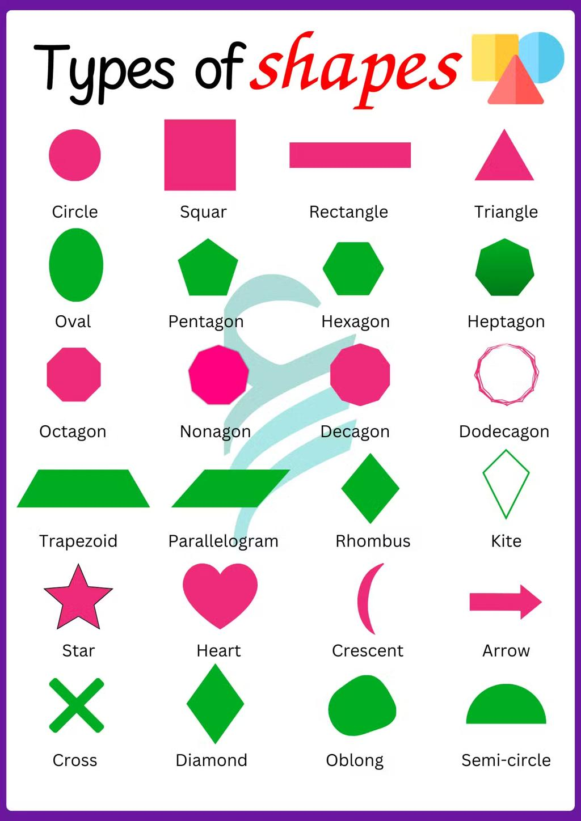
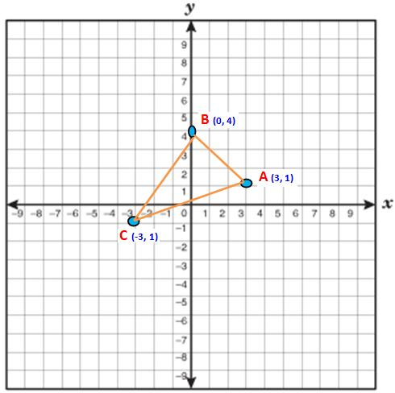
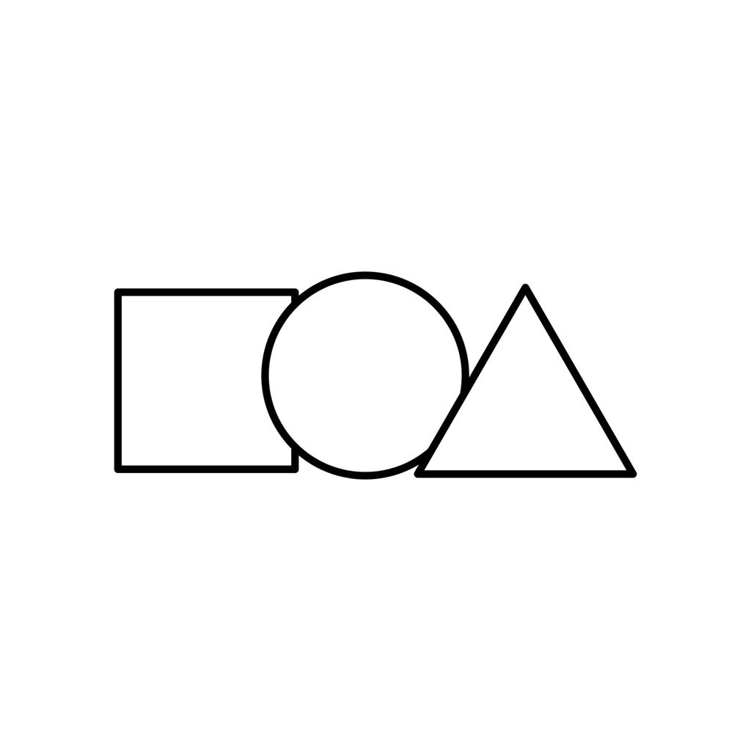
🧠 How they are represented:
- Using lines and curves
- Drawn on paper or screen (flat surface)
- Can also be defined using coordinates (x, y)
📌 Examples:
- Circle ⚪ → defined by center + radius
- Square ⬜ → 4 equal sides
- Triangle 🔺 → 3 connected points

🧊 2. 3D Shape Representation (Solid Shapes)
# Source: AI Source: Provided by: [Data Path: Persons Table -> ID Column: 1, Name_En Column: Motasem Essam] -> From: [ChatGPT] on [5/2/2026]
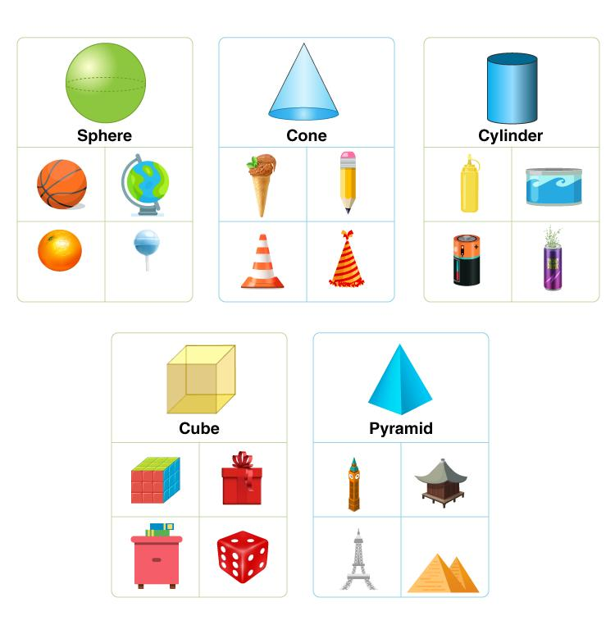
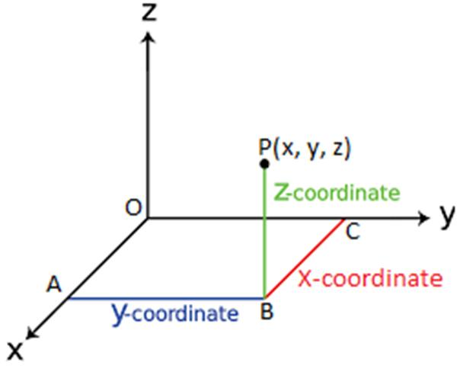
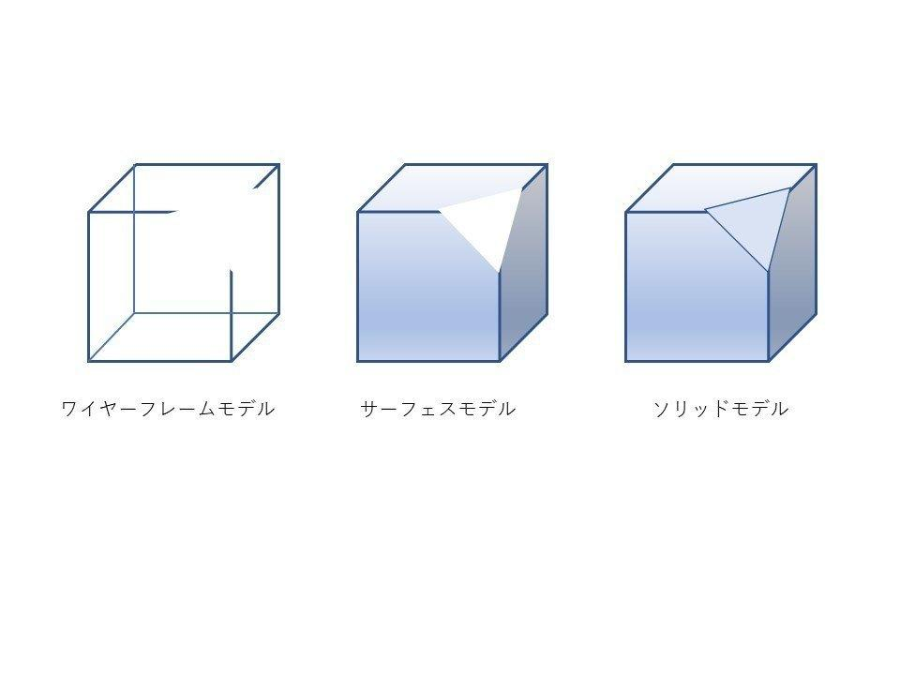
🧠 How they are represented:
- Using vertices (points), edges, and faces
- Defined in 3D coordinates (x, y, z)
- Can be shown as:
  - Wireframe (outline)
  - Solid model (filled surface)
📌 Examples:
- Cube 🧊 → 8 vertices, 6 faces
- Sphere ⚽ → curved surface defined mathematically
- Cylinder 🧴 → circular base + height

💻 3. Computer Graphics Representation
# Source: AI Source: Provided by: [Data Path: Persons Table -> ID Column: 1, Name_En Column: Motasem Essam] -> From: [ChatGPT] on [5/2/2026]
In computer graphics, shapes are represented using:
- 📍 Vertices → points in space
- 🔗 Edges → lines connecting points
- 🧩 Polygons (faces) → filled surfaces
- 📐 Mathematical equations → for curves and circles

🧠 Simple idea
# Source: AI Source: Provided by: [Data Path: Persons Table -> ID Column: 1, Name_En Column: Motasem Essam] -> From: [ChatGPT] on [5/2/2026]
- ✏️ Drawing → lines and curves
- 📊 Math → coordinates and formulas
- 🖥️ 3D graphics → points + edges + faces

🚀 In short:
# Source: AI Source: Provided by: [Data Path: Persons Table -> ID Column: 1, Name_En Column: Motasem Essam] -> From: [ChatGPT] on [5/2/2026]
Shapes are represented using lines, points, and coordinates in 2D, and using vertices, edges, and faces in 3D computer graphics.

⚙️ Key features
# Source: AI Source: Provided by: [Data Path: Persons Table -> ID Column: 1, Name_En Column: Motasem Essam] -> From: [ChatGPT] on [5/2/2026]
- 📏 Define the form of objects
- 🧩 Can be simple or complex
- 🎨 Used in both 2D and 3D design
- 🏗️ Building blocks of graphics

🚀 In short:
# Source: AI Source: Provided by: [Data Path: Persons Table -> ID Column: 1, Name_En Column: Motasem Essam] -> From: [ChatGPT] on [5/2/2026]
Shapes = the basic forms of objects, either flat (2D) or solid (3D), used to create everything in graphics and design.

